DBMS
LAB Assignment-2

- Create a table EMP1 with following structure.

ID | Name | Basic | Designation | Age

Column Description:-
ID Number (2)
Name Varchar2 (10)
Basic Number (6, 2)
Designation Varchar2 (10)
Age Number (2)
Query: CREATE TABLE EMP1 ( ID INT(2), Name VARCHAR(10), Basic DECIMAL(6,2), Designation VARCHAR(10), Age INT(2));

- Change the data type of the field Basic from float to integer with required size of the EMP1 table.
QUERY: ALTER TABLE EMP1 MODIFY Basic INT(6);

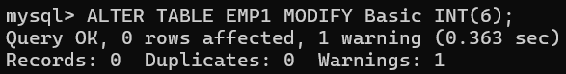

- Change the field size of Name column of the EMP1 table from 10 to 15.
QUERY: ALTER TABLE EMP1 MODIFY Name VARCHAR(15);

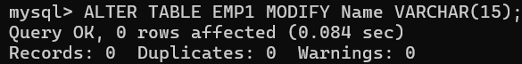

- Create another table EMP_trainee with the same (changed) structure. The column ID to be renamed as Emp_id in the EMP_trainee table.
QUERY: CREATE TABLE EMP_trainee (Emp_id INT(2), Name VARCHAR(15), Basic INT(6), Designation VARCHAR(10), Age INT(2));

- Insert following data in EMP1 table:-
(1, Rohit, 6700, Manager, 24)
(2, Sunil, 6200, Engineer, 27)
(3, Payal, 6300, Engineer, 25)
(4, Kunal, 6700, Trainee, 28)
(5, Sunita, 6230, Trainee, 26)
(6, Bimal, 7000, Trainee, 25)
QUERY: INSERT INTO EMP1 (ID, Name, Basic, Designation, Age) VALUES (1, 'Rohit', 6700, 'Manager', 24), (2, 'Sunil', 6200, 'Engineer', 27), (3, 'Payal', 6300, 'Engineer', 25), (4, 'Kunal', 6700, 'Trainee', 28), (5, 'Sunita', 6230, 'Trainee', 26), (6, 'Bimal', 7000, 'Trainee', 25);

- Insert all rows with the designation ‘trainee’ from the EMP1 table to EMP_trainee table.
QUERY: INSERT INTO EMP_trainee SELECT * FROM EMP1 WHERE Designation = 'Trainee';

- Add columns Skills (data type-varchar2 and size-10) and DOJ(data type-date) to the EMP1 table and add data for the Skills and DOJ columns according to your own wish.
QUERY: ALTER TABLE EMP1 ADD ( Skills VARCHAR(10), DOJ DATE);

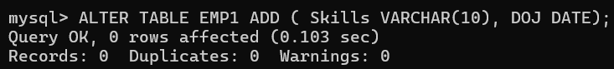

UPDATE EMP1 SET Skills = 'Java', DOJ = '2022-01-15' WHERE ID = 1;
UPDATE EMP1 SET Skills = 'Python', DOJ = '2021-02-20' WHERE ID = 2;
UPDATE EMP1 SET Skills = 'C++', DOJ = '2020-03-05' WHERE ID = 3;
UPDATE EMP1 SET Skills = 'SQL',DOJ = '2023-04-10' WHERE ID = 4;
UPDATE EMP1 SET Skills = 'HTML',DOJ = '2022-05-25' WHERE ID = 5;
UPDATE EMP1 SET Skills = 'JavaScript', DOJ ='2021-06-30' WHERE ID = 6;

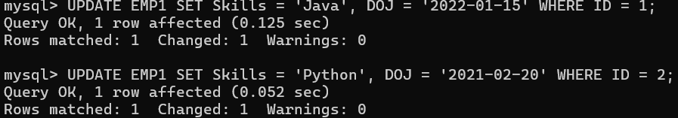

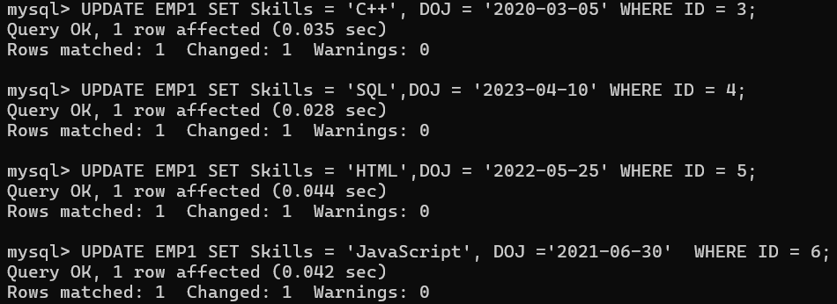

- Update more than one row in one query in EMP1 table.
QUERY: UPDATE EMP1 SET basic = 6600 where age<26;

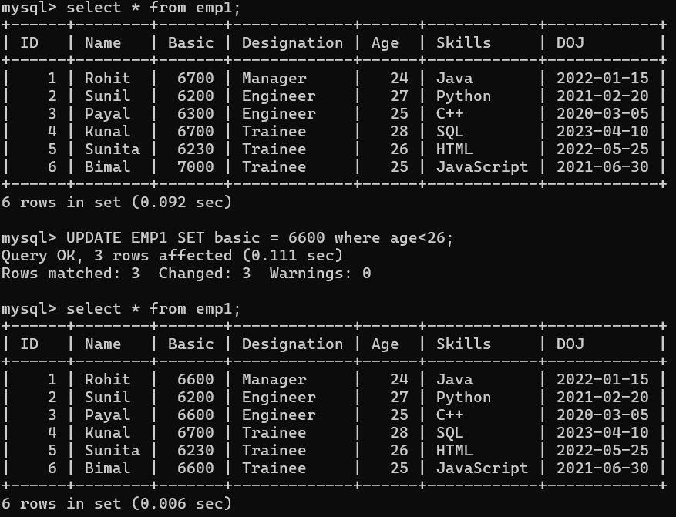

- Rename the column Age of EMP1 table to Age_in_Years.
QUERY: ALTER TABLE EMP1 RENAME COLUMN Age TO Age_in_Years;

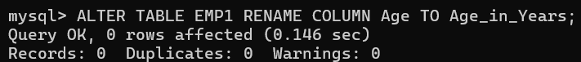

- Drop the Age column from the EMP_trainee table.
QUERY: ALTER TABLE EMP_trainee DROP COLUMN Age;

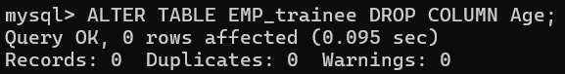

- Rename the table EMP to EMP_Mgr_Engr.
QUERY: ALTER TABLE EMP RENAME TO EMP_Mgr_Engr;

- Truncate EMP_Mgr_Engr table.

QUERY: TRUNCATE EMP_Mgr_Engr;

